  - Prototyping workshop
  - Learning material for the study module “Start-ups for sustainable environment created by youngsters”

  - PROTOTYPING WORKSHOPS
  - Learning material for the study module “Start-ups for sustainable environment created by youngsters”
Current learning material is prepared for the teachers of high-school and gymnasium level students participating in Interreg Central Baltic project CB851 “ChangeMakers - Start-ups for sustainable environment created by youngsters” to better understand Innovation Management. Materials are compiled by the experts of Riga Technical University and meant for two 90-minute lessons and is supplemented with presentation, available at the Interreg Central Baltic ChangeMakers project’s web page https://sites.utu.fi/changemakers/

Riga Technical University, 2021

Author of the learning material:
Jānis Lapsa

TABLE OF CONTENT
Proposed outline of the workshop 3
0 - PREPARATION 4
Homework prior to the workshop No 1 4
Preparation prior to the workshop No 2 4
I – Prototyping workshop no 1 5
II - HOME WORK AFTER PROTOTYPING WORKSHOP No 1 12
III – PROTOTYPING WORKSHOP No 2 13
IV - HOME WORK AFTER PROTOTYPING WORKSHOP No 2 15
V – ADDITIONAL MATERIALS 15

Proposed outline of the workshop
Table below proposes outline of the Prototyping workshop is divided in two parts and the estimated duration of each sub-session. In the following chapters, you can find the topics we recommend you cover under each stage. Material is meant for international teams connecting online but the same approach can be used for working in the class. Adaptions to the learning material are encouraged, please inform the CM team if you alter the materials, so we could consider the adaptions to be included for the course to be carried out in 2021.

Order | SUB-SESSIONS | Estimated duration
0 | Preparation: materials for hands on prototyping workshop and mentor team | Prior to class
I | Prototyping workshop No1: presentation and practical tasks | 75 - 90 min
II | Home work No1: validation with potential customers | After the class
III | Prototyping workshop No2: validation with challenge owners and experts, individual feedback session | 30 – 90 min
IV | Home work No2: improving prototype based on expert feedback | After the class
V | Additional materials

0 - PREPARATION
All students at the age of 15-18 are welcome to take part in the course. No previous experience is required. Only an open mind and curiosity to learn something new are needed to complete the proposed assignments.

Homework prior to the workshop No 1
The following materials are provided to each team as a starter kit*:
- 1 roll of paper tape
- 1 roll of double-sided tape
- 20 fasteners
- 3 sticks of modelling clay
- 20 wooden sticks
- 2m of thread
- 1 m of wire
- 1 marker
- 3 color sticky notes
- 5 color markers
*other materials that are easy accessible can be used – card bord boxes, color paper, scissors and all the other creative things that might be useful and be upcycled. You are welcome to be creative!
Mentor team
Each team should have access to mentor that guides the prototyping journey and helps defining each team's idea and how it can be showed in a step by step story that includes physical prototype.
Each team should have an individual mentor or one mentor for 2-3 teams.

Preparation prior to the workshop No 2
In this workshop students have to present their validated prototype to challenge experts. For that to succeed challenge experts have to be invited to the workshop session. The best way for students to have better understanding of their ideas success, experts from different fields should listen and give feedback via virtual or paper feedback forms. It is suggested that all challenge experts listen to all presentations. If it is not possible, experts from different fields should be invited. Additionally other students can give feedback via feedback forms.

I – Prototyping workshop no 1
Estimated duration of the session ~90 minutes
Slides: Prototyping.pptx

Introduction
In this workshop students are introduced with the basics of prototyping and its importance in product development. Students work in a team to create a physical or digital prototype for their proposed solution. The emphasis is on team work and hands-on “dirty” prototyping where students are challenged to create a basic prototype in a short amount of time.
The assignment
Students have to create a prototype that demonstrates their proposed solution to the problem they are solving. Teams have to get creative and use whatever materials and tools they have available - physical or digital. The prototype has to be presented at the end of the workshop.
Desired outcome
Teams are able to create a basic prototype with simple tools and materials to communicate and validate their ideas for solutions. Students have a clear understanding of the importance of prototyping and how to approach it in problem solving.

Prototyping workshop No1 time plan
Activity | Time needed | What is done? | Comments
Gathering | 00:00 -  5 min | Students are let in ZOOM 5 min before | Instruct students to put their team number in front of their name (3 John Doe)
Intro | 00:00 - 00:10 | Hello, introduction to the plan for next 2 weeks prototyping
Presentation | 00:10 - 00:30 | Short presentation about prototyping | Use the provided presentation with examples and notes
Assignment given | 00:30 - 00:35 | Students are introduced with prototyping assignment that they have to do in this workshop
Prototyping with mentors | 00:35 - 01:10 | 50 min to do it, each team has separate breakout room and a mentor | Mentor guides the team in prototype creation – what could be built, what tools could be used and how could it be presented.
Prototype presentation | 01:10 - 01:25 | Each team has ~1 min to present what have they done | Presentation:  1 sentence of what is the problem  What is your solution?  Done while showing the prototype (yes it can be done)
Saying goodbye | 01:25 - 01:30 | Last words, reminder about homework | Home work assignment (see below)

Prototyping workshop No1 presentation notes
No. | Slide | Notes
1 | 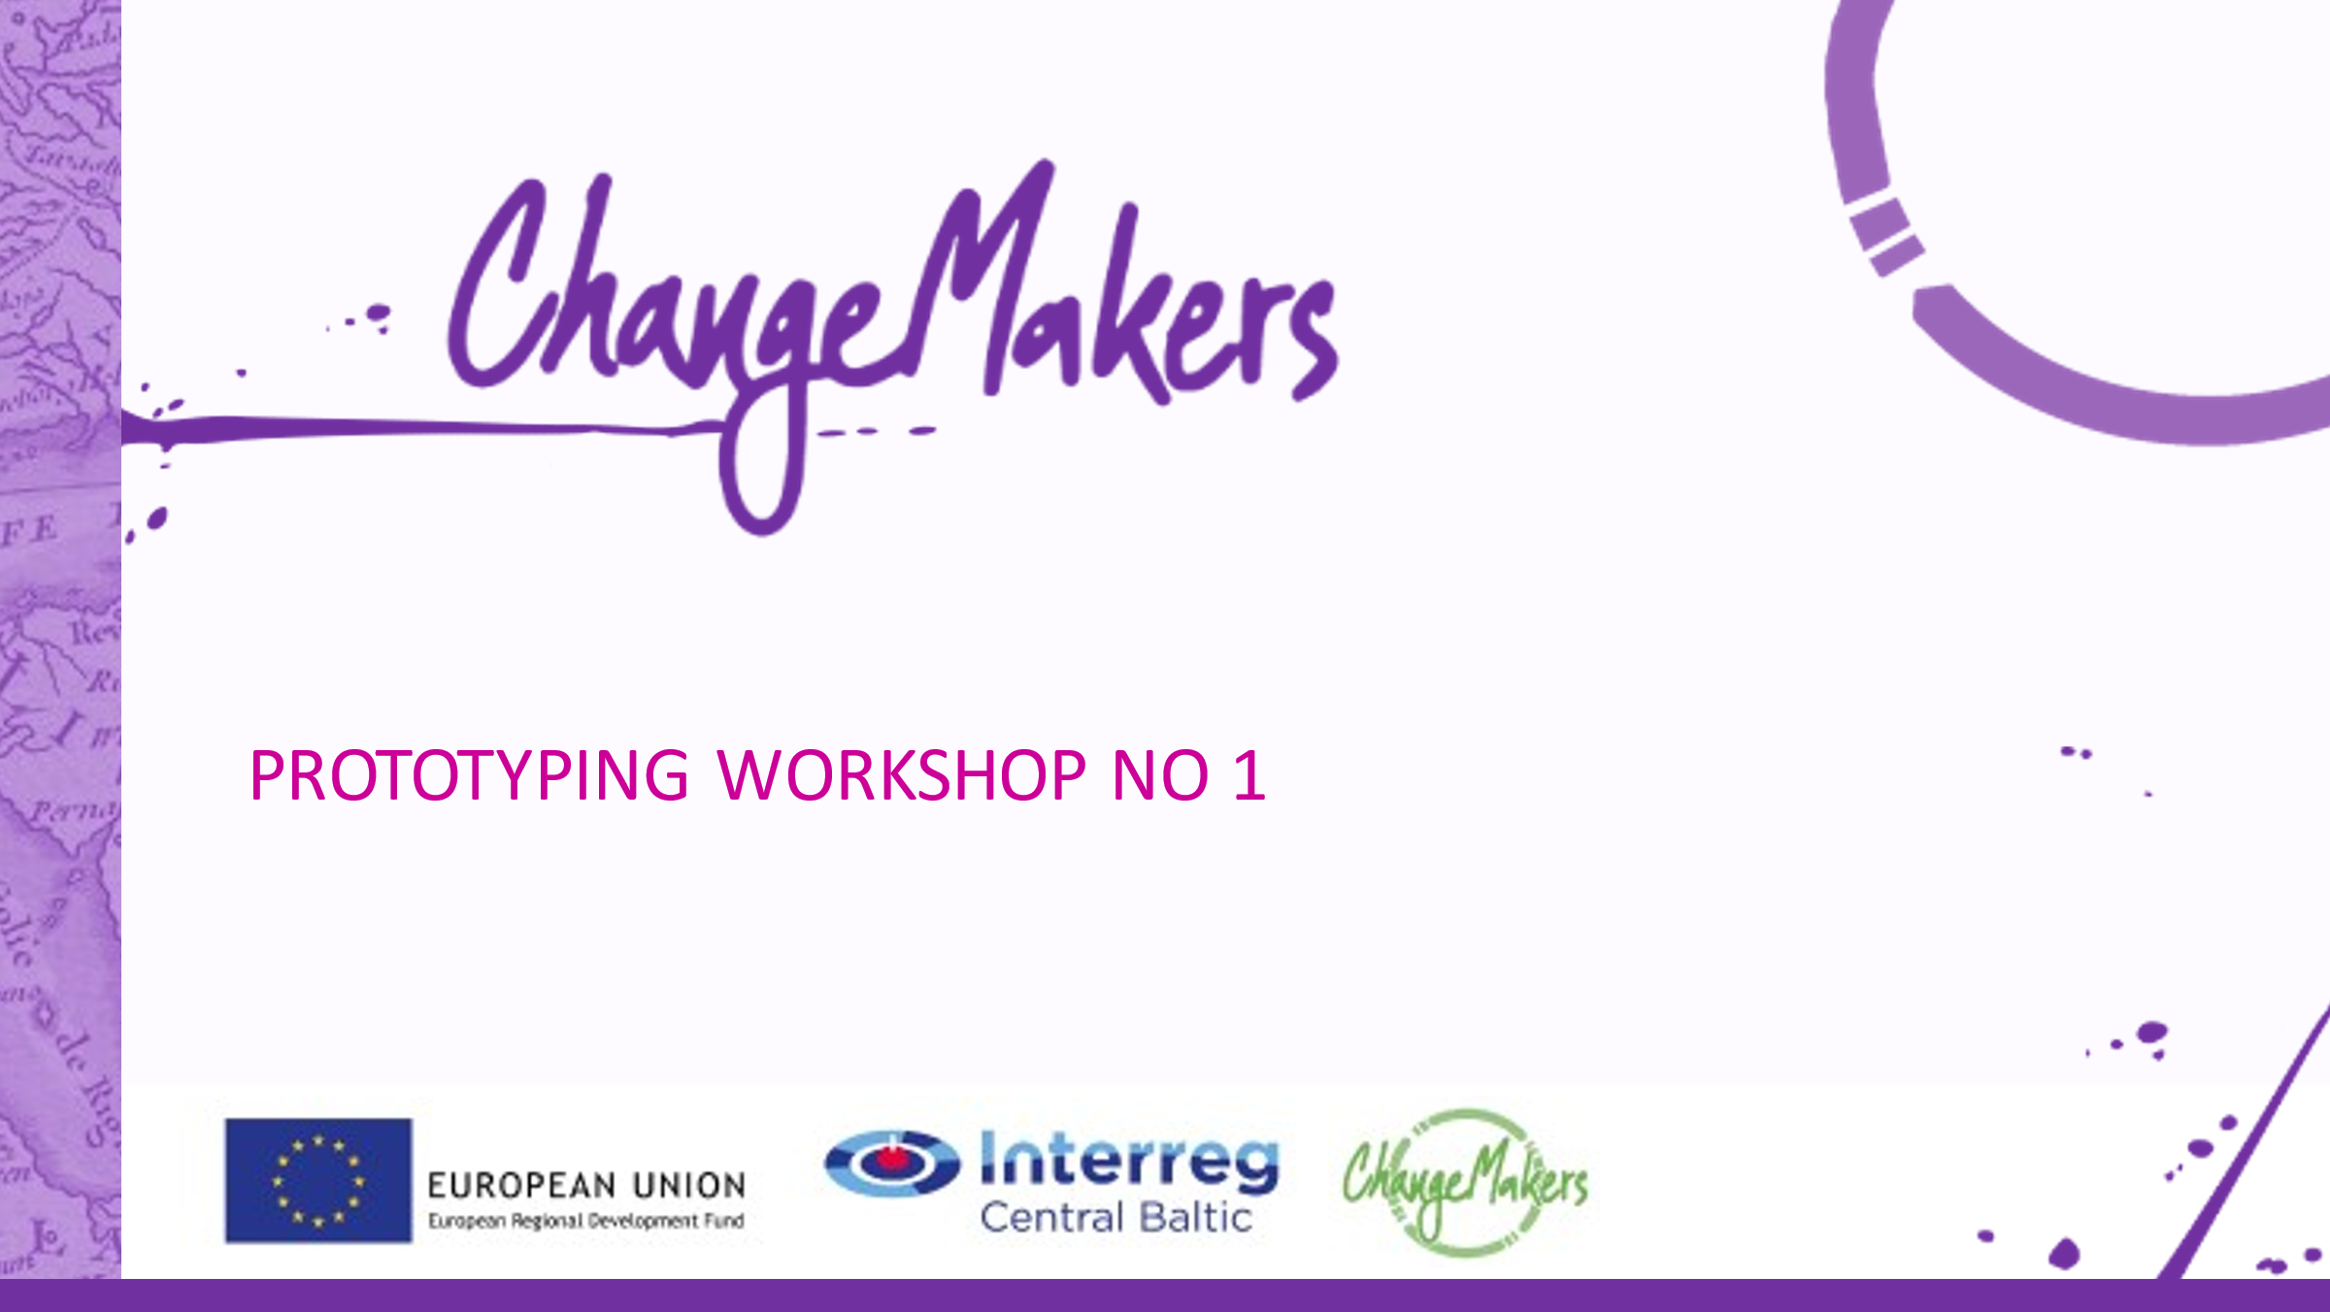
2 | 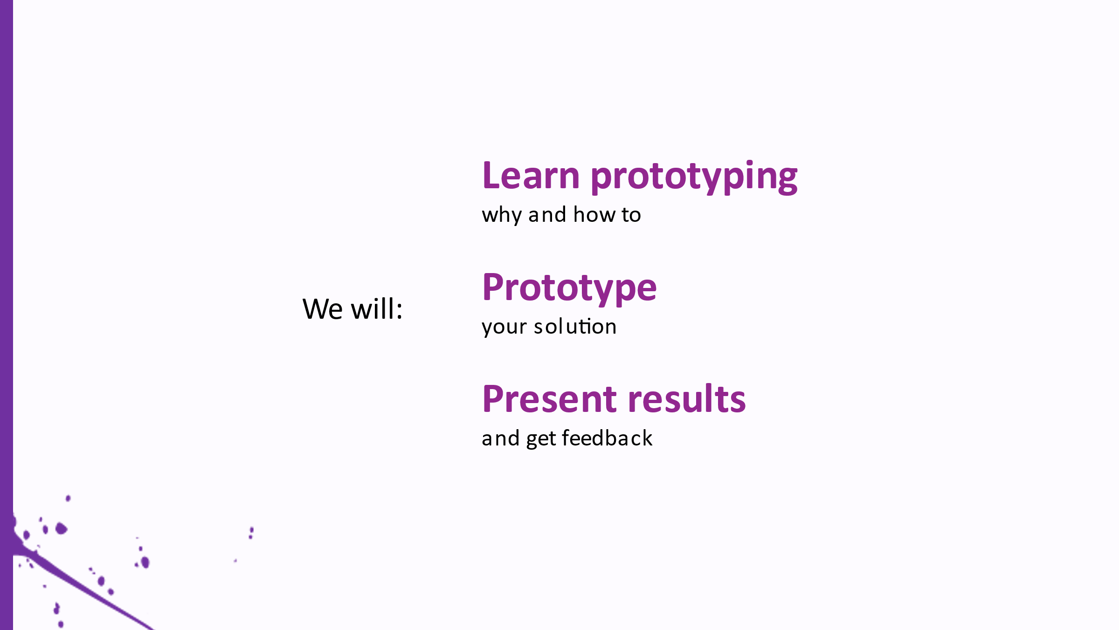 | Explain that todays’ main goal will be to prototype the ideas they had as solutions for the challenge. They will learn why is prototyping is needed in design process and how to do it.
3 | 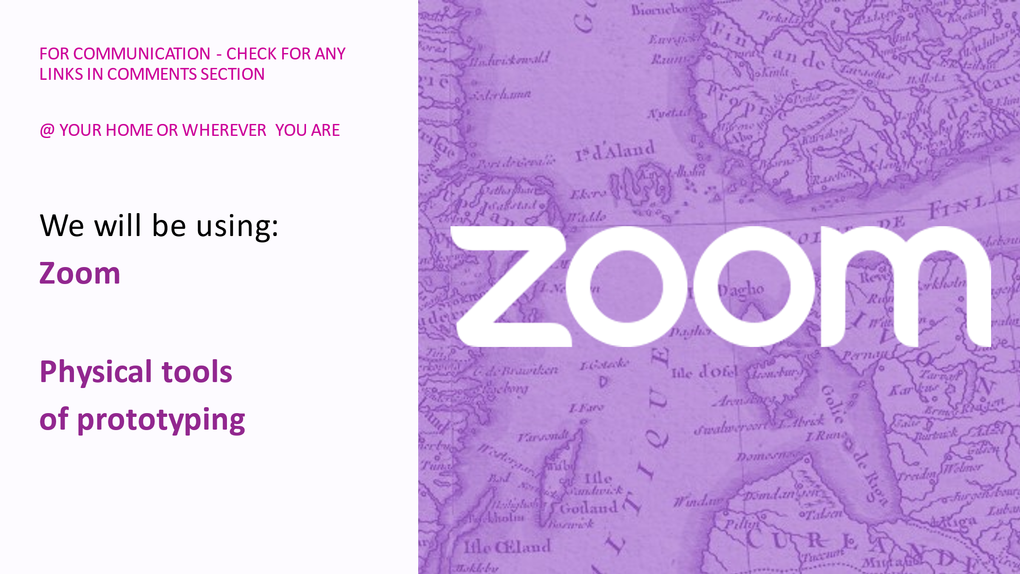 | You can remind that some basic crafting tools like scissors, rulers etc. will be needed. That they will work in breakout rooms and they can split the prototype into multiple parts that can be divided between the team members.
4 | 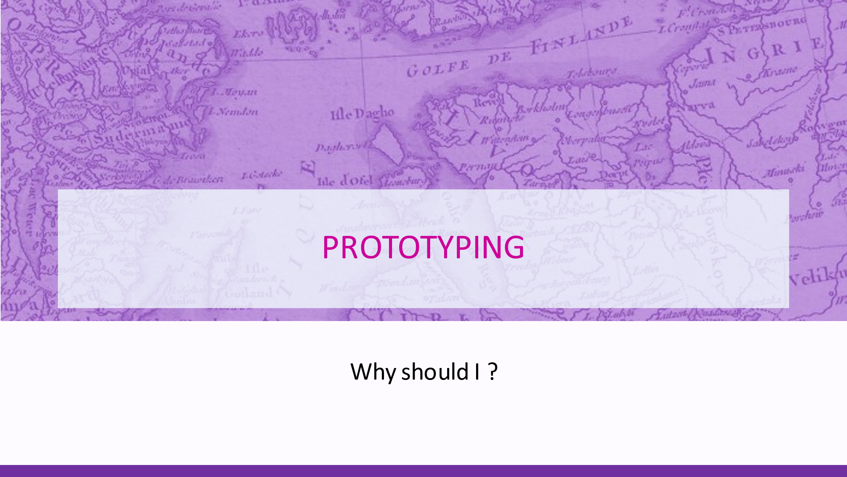 | Shortly present what is prototyping and why should you prototype your ideas.
5 | 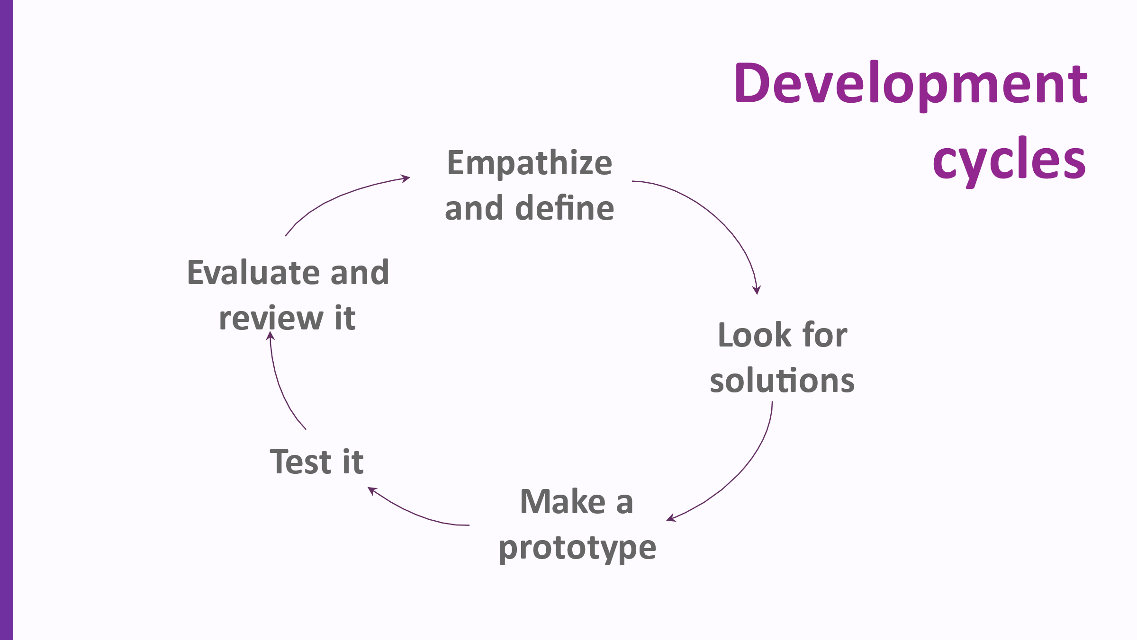 | Prototyping is part of a healthy product development cycle. You must always have a clear idea on what is the problem you are trying to solve, how does it impact the user and what would be the user preferences. After you have defined the problem you are solving, you look for different solutions, this part is creative and requires you to be open minded and ready to unleash your fantasy. After you have generated enough solutions you evaluate them, trying to establish which ones would work really well in the specific situation and you narrow down to one or a few ideas. After you have a clear picture of what is the problem you are trying to solve and what could be the best solution for it, it is time to start prototyping. You then use the prototype to test out its functionalities and how well it solves the problem. It is best to test it out with the potential users. It allows you to get valuable feedback on what needs to be changed so that you know what to work on next.
6 | 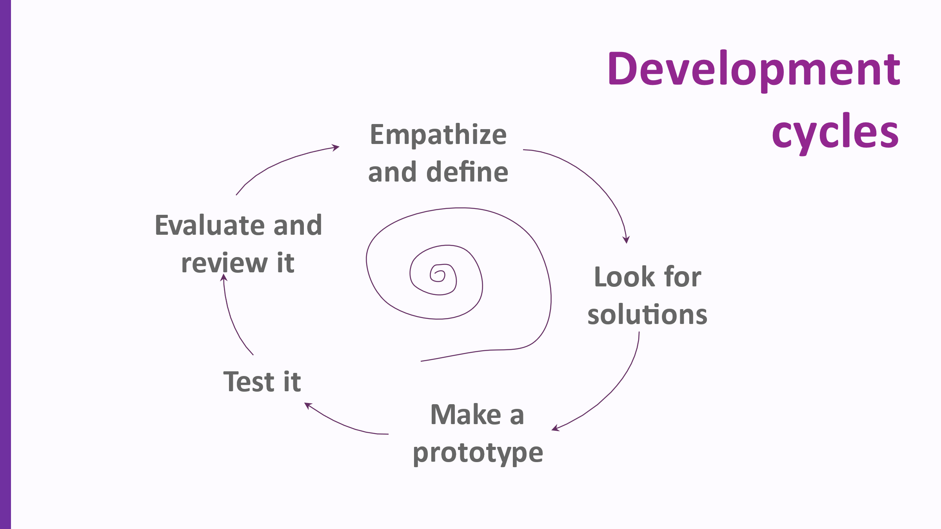 | These five steps are not a complete process, because normally they are repeated over and over again until a result suitable for the task is achieved. Meaning, after evaluation of the previous iteration you define new problems to work on and start looking for solutions for them.
7 | 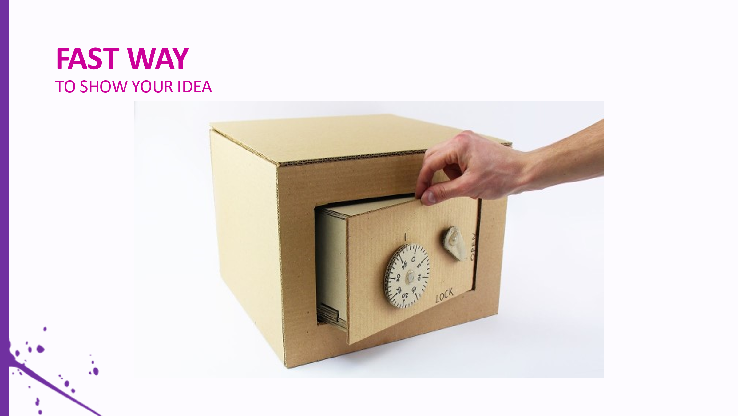 | Prototyping can be a fast way to materialize your ideas. With prototype it is easy for you to explain your idea to someone, test it and get valuable feedback. It is useful to make first prototype using simple materials and prototyping techniques, because it allows you to save money and time while still giving the chance to communicate your idea to others and test it.
8 | 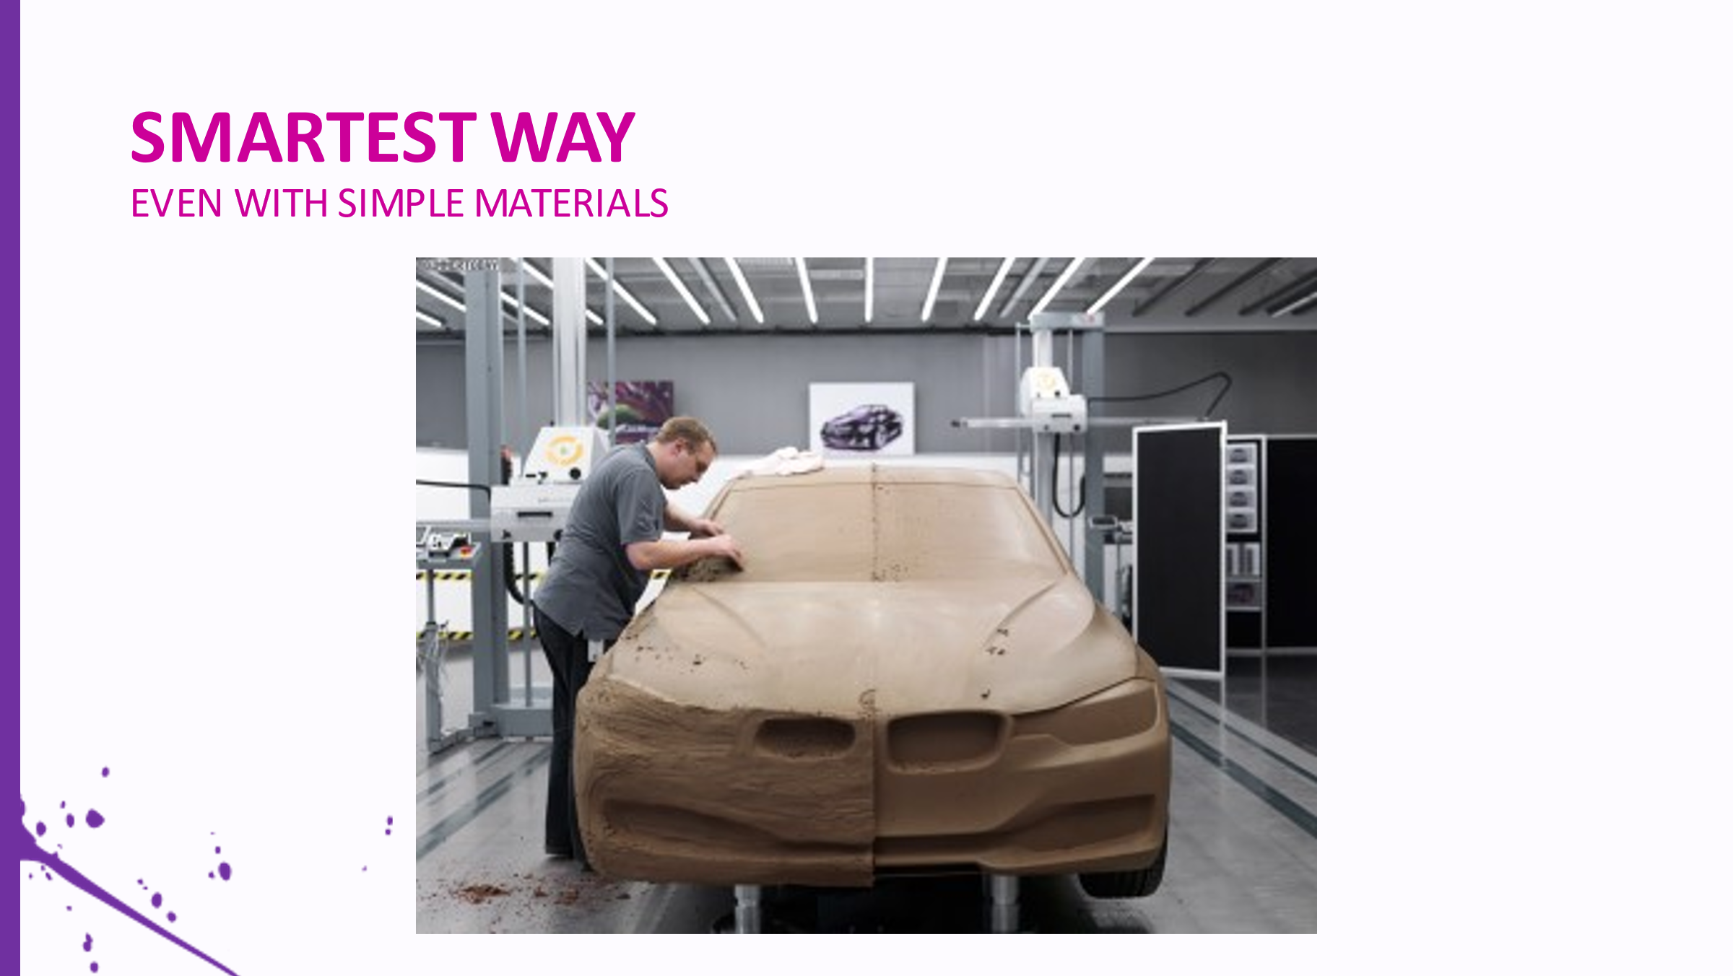 | Sometimes even complex results can be achieved by use of simple materials. You shouldn’t worry about using simple materials and your first prototypes not looking very good, because the goal of the first prototypes is always to help you get answers to the questions you have.
9 | 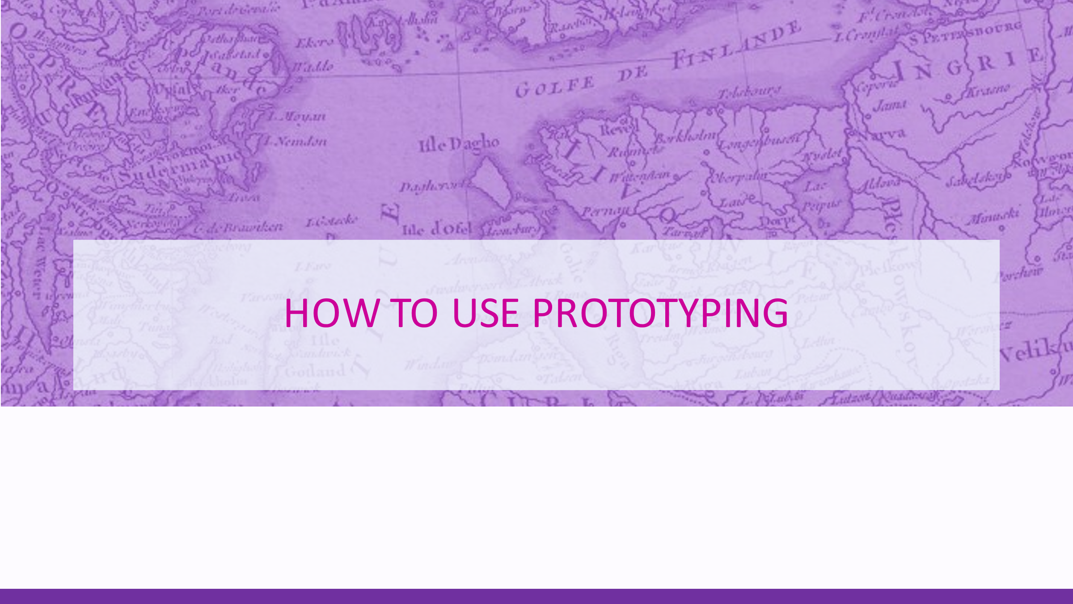
10 | 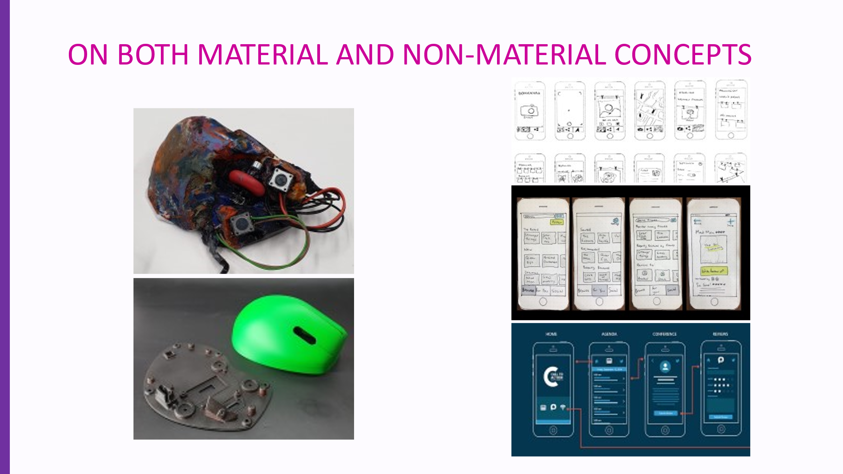 | Prototypes can serve many different purposes, the goal of making one should define the used materials and prototyped content. Also it is important to understand that prototypes can be made not only for tangible objects, but also for services, apps and other non-material concepts. Prototypes for physical products can be made to determine or define size properties, shapes, ergonomics, function defining features like mechanical or electronical parts and systems and other features. It can be used as a tool to make decisions on properties that are not clear to you, for example, it would be hard to model an ergonomical mouse in the 3D environment because you have to actually touch it to understand how it fits in your hand, are the buttons easy to reach and click etc. At the same time, you could integrate electronics in that same mouse to find the best arrangement of the circuit board, batteries and buttons. Alternatively, creating a prototype of an app or a service can allow you to understand the structure of your creation, model and test different user scenarios and the overall usability and understandability of your concept. The way an app works can be shown by using cardboard cutouts of a mobile phone and drawing different screens that the user would see after clicking specific buttons.  Alternatively, a service can be explained and tested by creating a material representation of it’s business model or the way it would work, by creating separate parts of the process and showing how they interact, for example, to explain how a user would find a sticker with QR code on your package that would lead to a page with valuable information about the use of your product together with a gaming section to target younger generation and allow them to collect points that could be used to get valuable discounts on your products, therefore keeping their interest on your product. Prototypes of services are not that intuitive, a person has to explain what is happening to a potential user to let them experience the way a service works and feel the need for it, yet it allows to get that very much needed feedback from them to improve your concept.
11 | 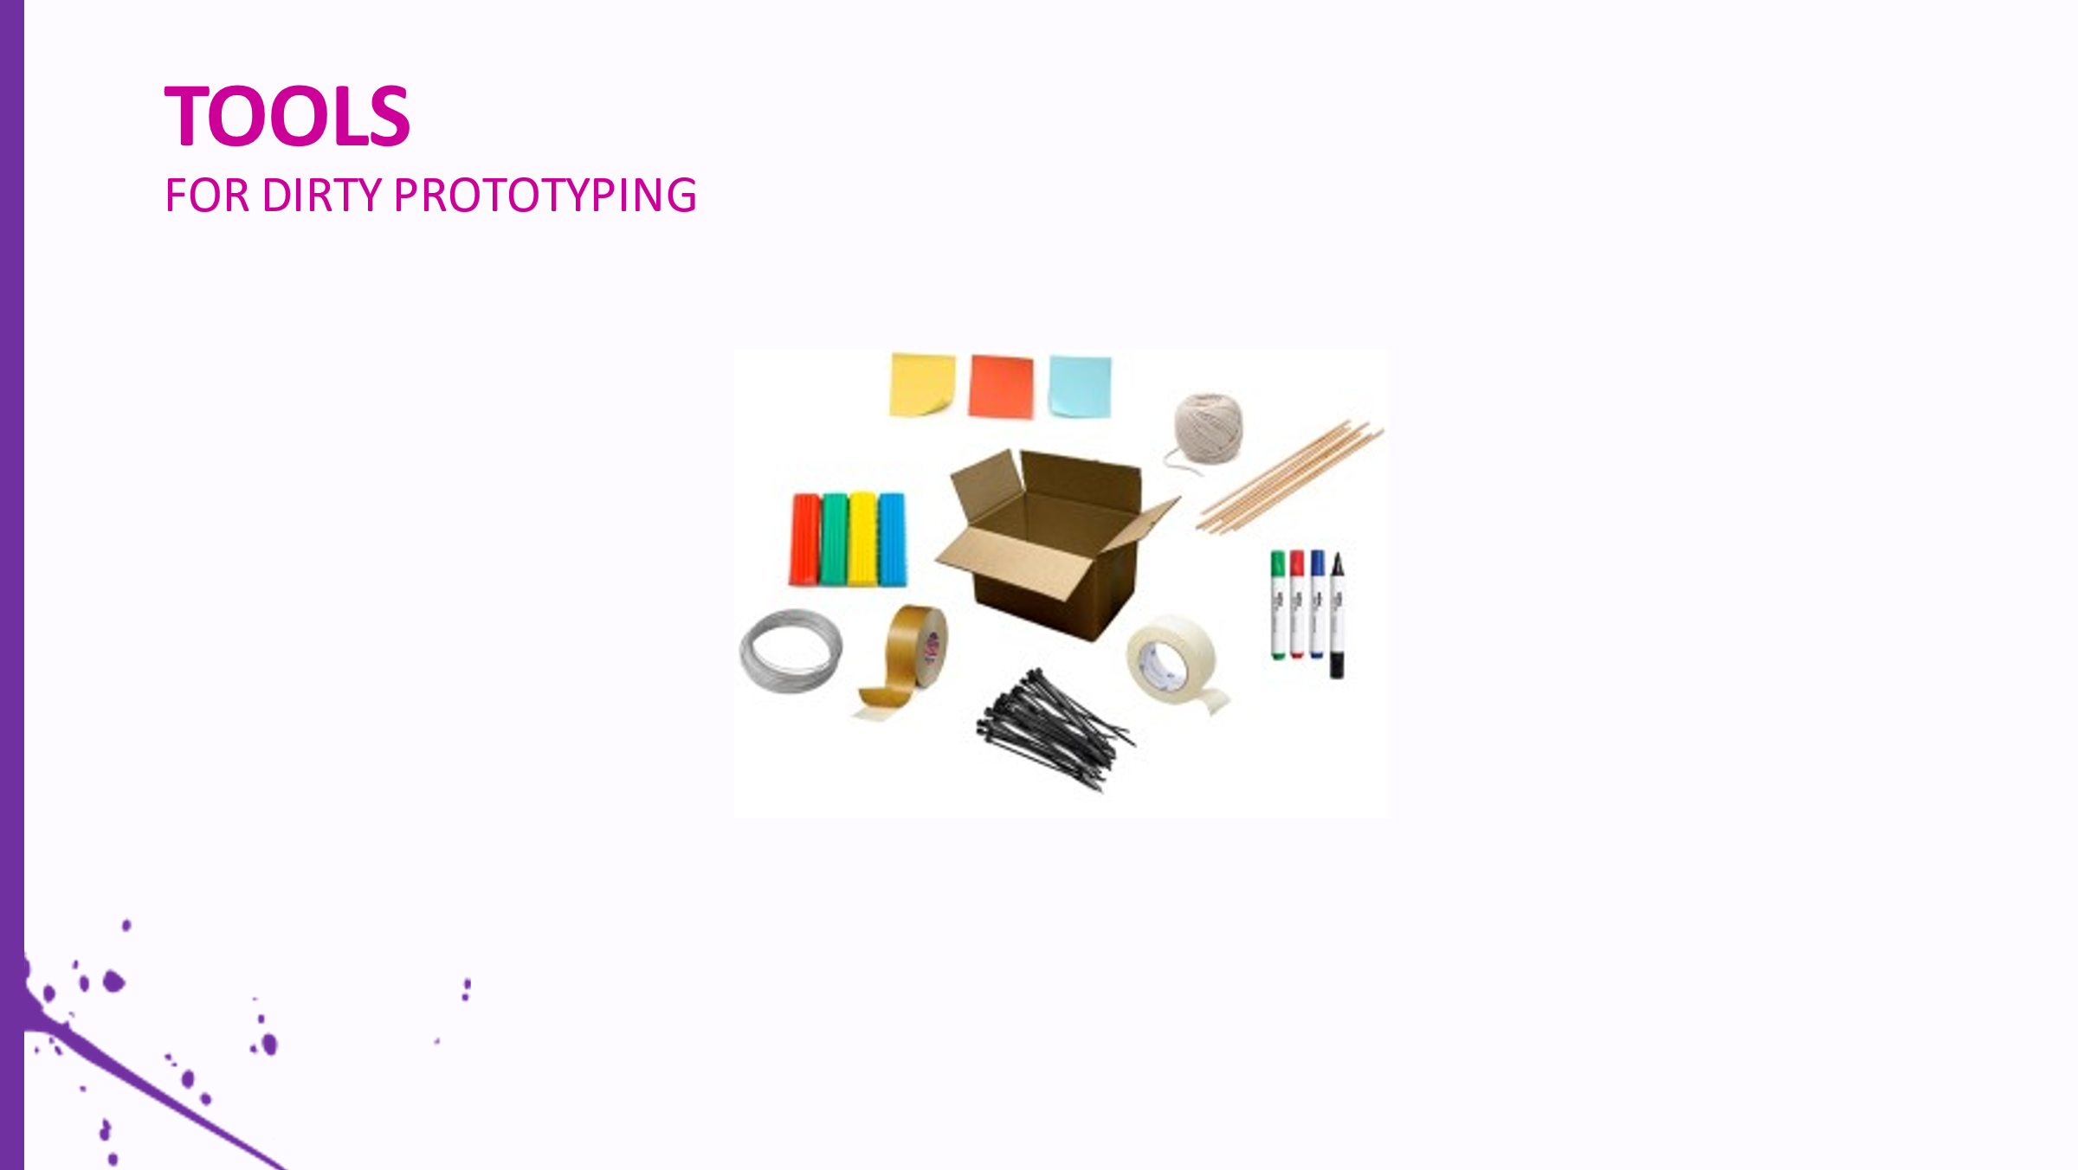 | The rule of dirty prototyping is to make the most out of tools that you have, which means, you will have to use the tools provided…
12 | 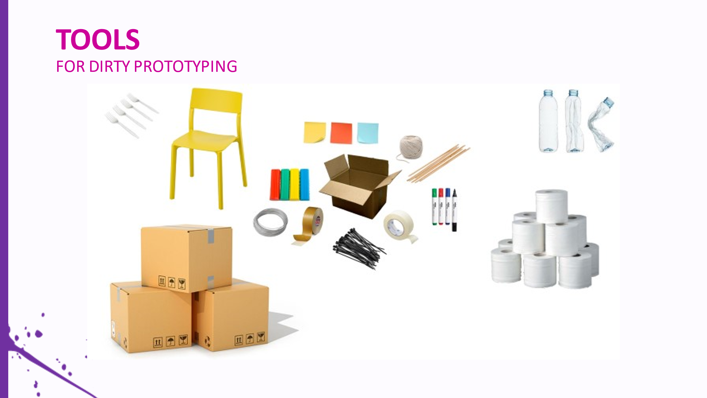 | … in combination with anything else that is available to you. By thinking creatively, you can use items found at home or in your classroom that have the right properties, like water-tight paper cups, the cardboard toilet paper roll core or a shoebox to save time on making basic elements out of scrap.
13 | 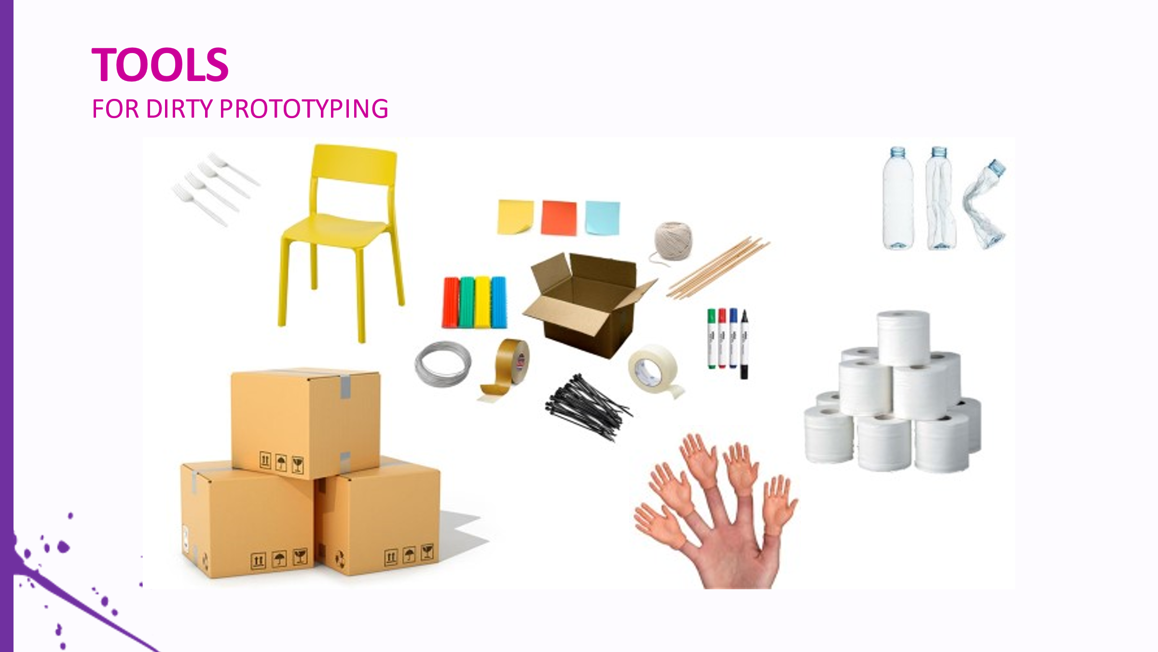 | Most importantly, use your head and your hands, remember to divide the tasks between group members to achieve maximum results in the limited time period.
14 |  | Explain how students from previous workshops dealt with this challenge and show some of the most creative prototypes.
15 | 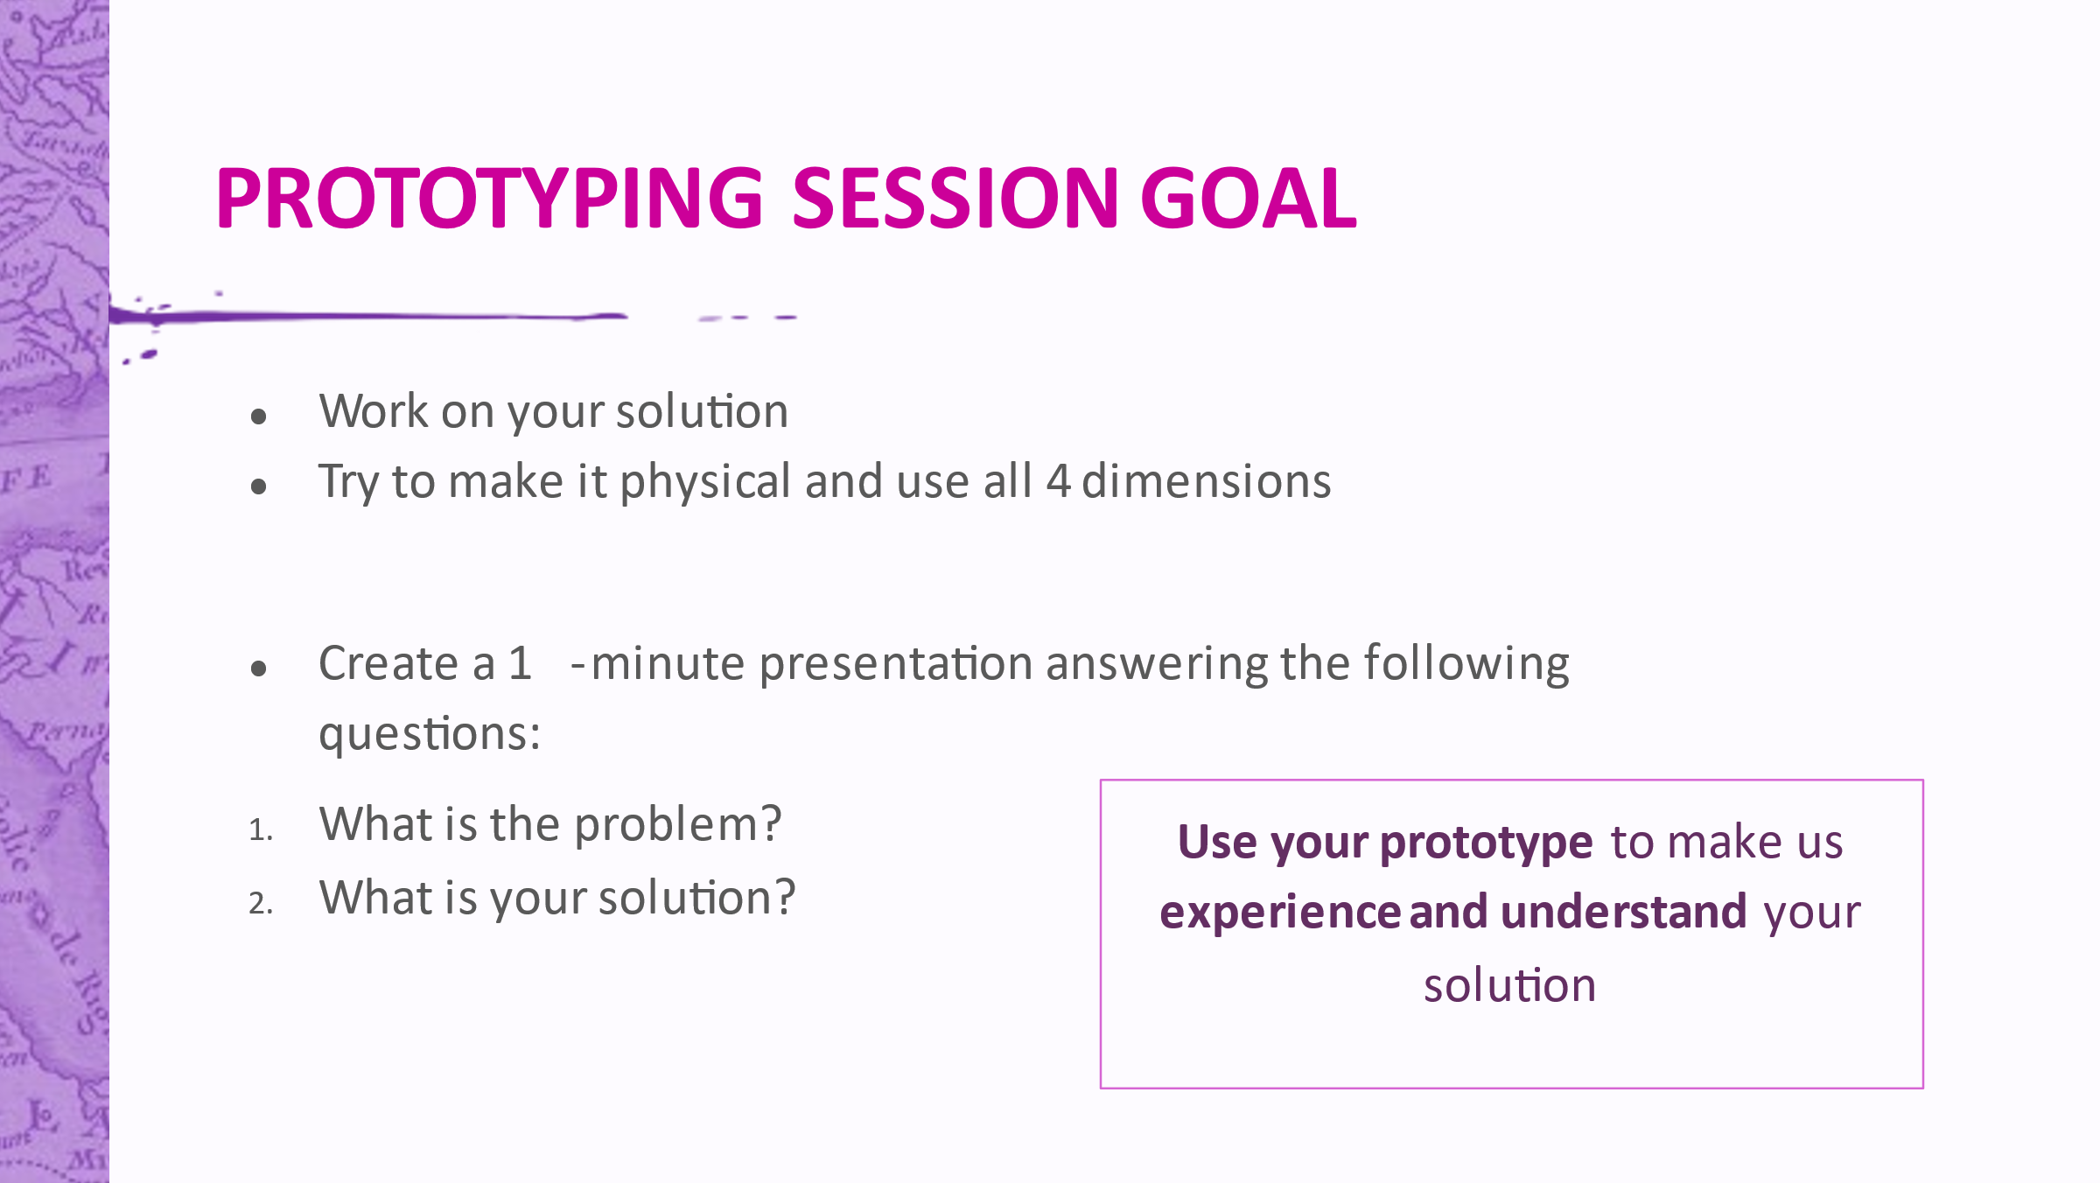 | Now it is time for doing some prototyping. You will have to prototype your solution, to be able to explain how it works and get initial feedback from your coursemates. Make it tangible and try to use all four dimensions (use the time you have presenting it) – try to make it interactive so that you cold show and explain, how it works. You will also have to prepare a 3 minute presentation answering the following questions … Don’t make it in Powerpoint, you will have to turn on your camera and present by using what you have made.
16 | 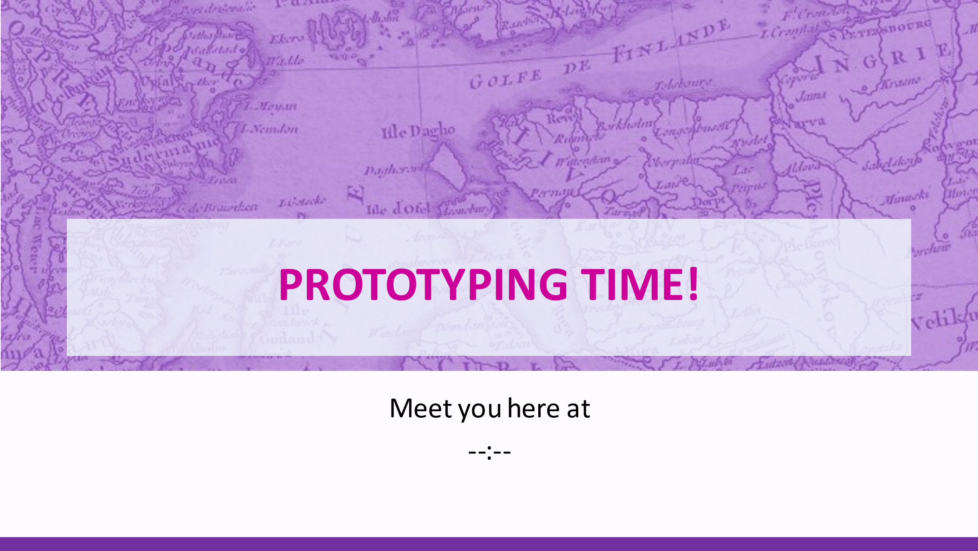 | You will now have time untill … to work on your prototype.
17 | 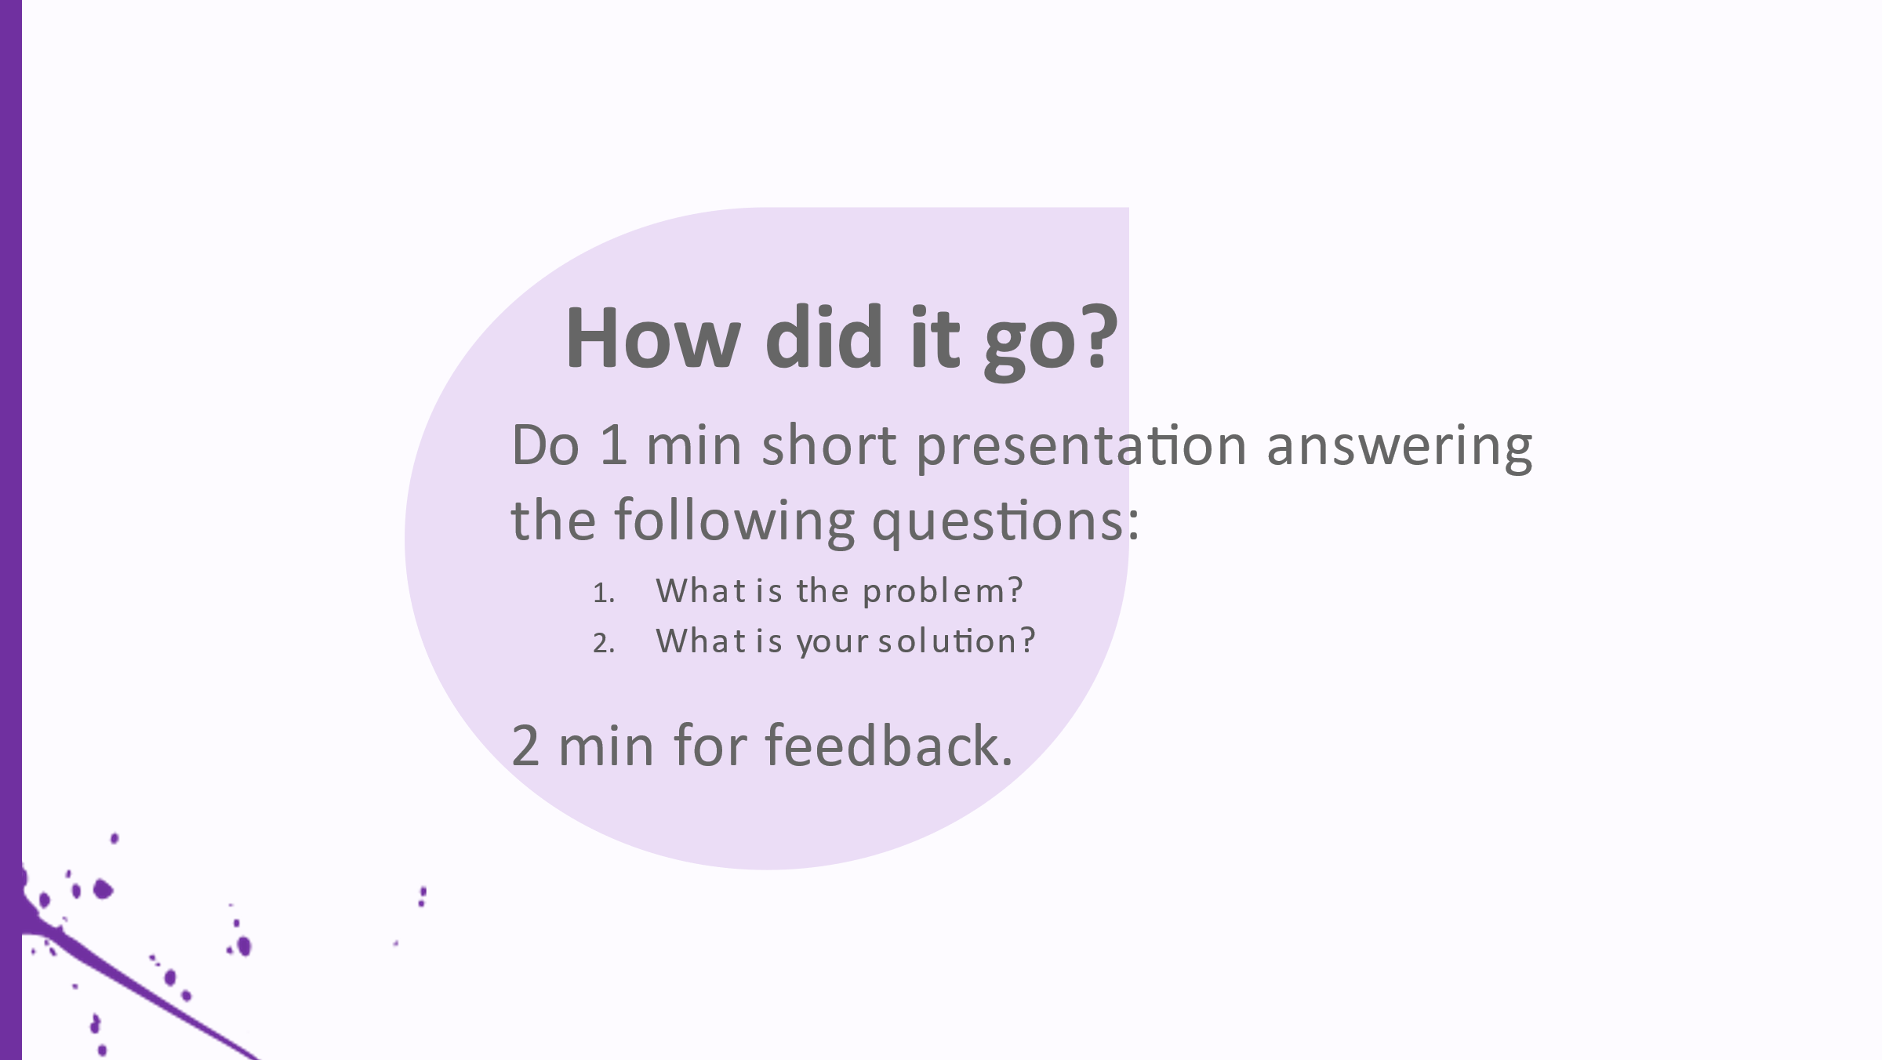 | Now it is time for short presentations. It is valuable not only to present but also to learn to give feedback, so we will ask the group that presents give feedback to the next group after they present. Meaning, the last team to present will give feedback to the first presenters, the first team to the second team etc.
18 | 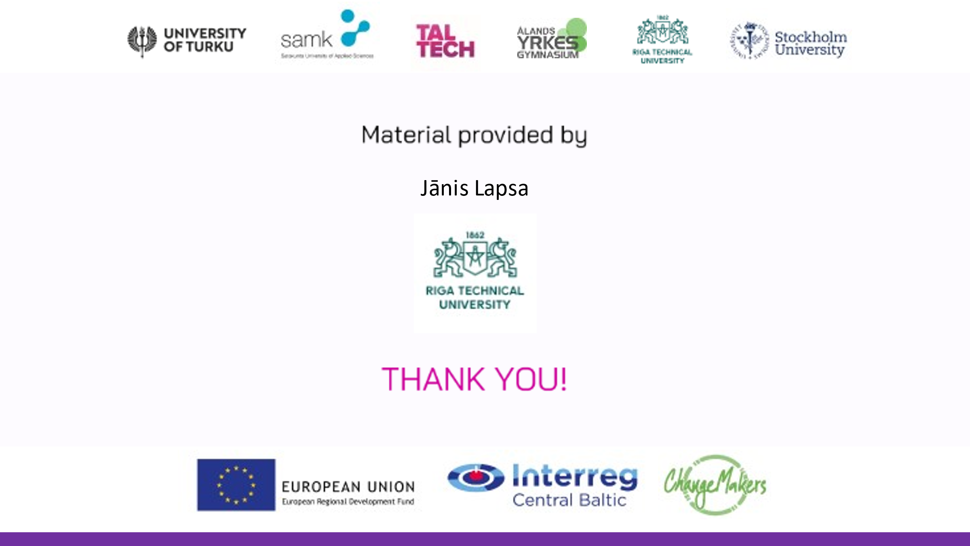 | Last words, reminder about homework.

II - HOME WORK AFTER PROTOTYPING WORKSHOP No 1
- Improve the prototype and validate it with potential customers (piers, parents, teachers, mentor etc.) individually or in a team.

- Have a team meeting and talk about validation results and what needs to be improved.

- Prepare a 5 min presentation in a team:
-What is the problem they are solving?
-How did they get to the solution to the problem?
-What is the solution?
-What kind of validation and with whom they had?

III – PROTOTYPING WORKSHOP No 2
Estimated duration of the session ~90 minutes

Introduction
In this workshop students have to present their validated prototype to challenge experts.
The assignment
For students:
- Present their validated prototype;
- Give feedback to other piers.
For challenge experts:
- Give feedback to all presenting student teams.
Desired outcome
Teams are able to gain feedback from different fields, especially from their challenge expert, to validate their ideas business potential.

Prototyping workshop No 2 time plan
Activity | Time needed | What is done? | Comments
Check in with experts | 00:00 –  5 min | 10 min before Zoom all the experts gather together, they get explanation about what will happen and what we are waiting from them
Gathering | 00:00 –  5 min | Students are let in 5 min before
Intro | 00:00 - 00:10 | Hello, introduction to todays plan and how it will go
Presentations | 00:10 - 0:55 | 9 teams are presenting, each team has 5 min for presentation, experts just make notes for themselves. | All the teams are divided in 3 breakout rooms, each room 9 teams.  Different field experts listen to teams, purpose – to have a broad opinion  Experts write down notes for all team and send them later via email to mentor (or teacher, who collects feedback forms). Questions and notes are given to team mentors to talk out in mentoring session.
Team discussion with expert | 00:55 - 1:25 | Each topics expert is put in a breakout room and all the teams related to the topic join and can talk to the expert.
Saying goodbye | 01:25 - 01:30 | Last words, reminder about homework | Homework:  1) Meeting with mentor  2) Finishing prototype
*Proposed dividing in groups is based on number of 27 teams in a Zoom platform

IV - HOME WORK AFTER PROTOTYPING WORKSHOP No 2
- Mentor (or teacher, who collects feedback forms) sends to their teams feedback from all the expert comments

- Team meeting with mentor to talk about received feedback.

- Improve prototype and business idea.

- Submit video, picture or homepage or drawing of prototype by 26.02.2021 that is upgraded after expert feedback and mentor session.

V – ADDITIONAL MATERIALS
Good tools for application prototypes where you can develop really nice looking and functional wireframes:
https://whimsical.com/wireframes
https://www.figma.com/
https://www.mockflow.com/

Build your prototypes quickly, share them immediately, keep learning:
https://www.designkit.org/methods/build-run-prototypes

Prototyping workshop No 2 feedback form

Place:
Who is attending? Students, challenge experts, teachers, mentors
Your name:
Team number | Feedback of the team

The study material does not propose the possible breaks that might be needed to keep the focus and good pace. Teachers are expected to estimate the need for breaks based on school and group specific needs.

