  - ENTREPRENEURSHIP
  - I & II

  - Learning material for the study module “Start-ups for sustainable environment created by youngsters”

Entrepreneurship

i & ii

  - Learning material for the study module “Start-ups for sustainable environment created by youngsters”

Current learning material is prepared for the teachers of upper secondary and vocational education students participating in Interreg Central Baltic project CB851 “ChangeMakers - Start-ups for sustainable environment created by youngsters”. Materials are compiled by the experts of Satakunta University of Applied Sciences and meant for two 45-minute sessions. Supplementary educational tools such as texts, PowerPoint presentations, video clips, exercises and assignments are also prepared to support this material. All materials are available at the Interreg Central Baltic ChangeMakers project’s e-learning platform: https://newsub.samk.fi/changemakers-eplatform/

Satakunta University of Applied Sciences, 2021
Olena de Andres Gonzalez
Ollipekka Kivin
Nina Savela

Table of Contents

Outline for SESSION 1 4
Discussion: What are the reasons for becoming an entrepreneur? 5
0 – Preparation 5
What Defines Entrepreneurship? 6
What are the Most Important Skills Entrepreneurs Need? 7
Business Plan 9
Outline for SESSION 2 13
0 preparations: lessons learned from the last time 14
What is The Strategy and why do you need it as entrepreneur? 14
Entrepreneurship and circular economy business models 16
Appendix I 20
Appendix II 22

Outline for SESSION 1

Table below summarizes the outline and estimated time for the entrepreneurship lesson for session 1. Topics and materials related to each chapter are presented in the following sections. Adaptions to the learning material are encouraged. Please inform the ChangeMakers team, if you had to significantly alter the materials. That supports improvement of the original materials.

This project’s “ChangeMakers – Start-ups for sustainable environment created by youngsters” lesson is supposed to give a basic understanding about entrepreneurship: what it requires to be an entrepreneur and what skills you need when you’re starting a business.

Order | Chapter | Estimated duration
0 | Preparation: Discussion – what it means to be an entrepreneur? | 10 (min)
I | What Defines Entrepreneurship? What are the most important skills entrepreneurs need? | 15
II | Business Plan (One-pager) | 15
III | Questions and answers | 5

Discussion: What are the reasons for becoming an entrepreneur?

0 – Preparation

Slide 1-7:
Practical task: Describe in 1-3 words: What are the reasons a person would choose to become an entrepreneur? What does entrepreneurship mean for you? What could it bring to you? There are no right or wrong answers!
For this exercise you may use Mentimeter (familiar from the Cross-cultural communication lesson):
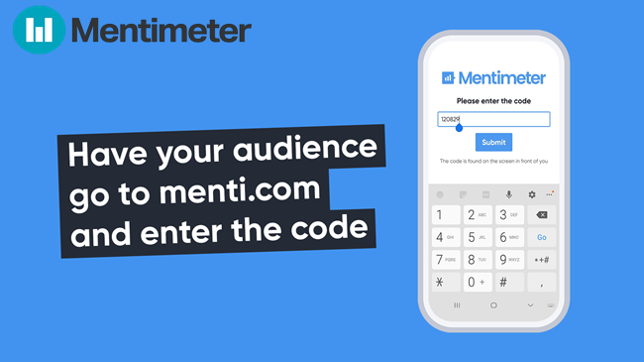
TIP!

Teacher collects results of the discussion (words) on a board at Mentimeter or in other visual way.

- A list with different motives to be an entrepreneur, which could be added on a board after students finish their task:
- Flexibility. Work your own hours.
- Financial independence. No one else is signing your pay checks.
- Freedom and being your own boss.
- Pursue your passion. You can do what makes you happy.
- Improve your industry. Push your industry forward with new innovations and ideas.
- Create something from scratch. Watch your organization grow from start to finish.
- Meet new people. Network with other entrepreneurs and professionals.
- Help people. Use products and services to improve people’s lives.
- New challenges every day. Find new ways to stimulate your mind.
- Work from anywhere. Work from home, an office or a beach if you so choose.
- Reach your dreams. If you’ve ever dreamed of being wildly successful, this is your chance.

Teacher can create a couple of examples. One of examples could be from the popular opinion, like Independence. Other example could be made for something rarer, like possibility to have a Personal brand.

Conclusions: Some of these motives fit you and some not at all, and this is the core idea of being an entrepreneur. Because everyone is looking for something very own and personal in Entrepreneurship, something that you can never have as a traditional worker.

Recommended video: What is an entrepreneur? https://www.youtube.com/watch?v=92ZmzD70sOU

Tip! Here and in a further chapters teacher can find a recommended video. Please be aware, that only one video can fit in the time- frames of the lesson. Choose what video and from what chapter you prefer to show to the students. All videos could be found at the ChangeMakers E-platform. All videos have been carefully chosen to support a learning materials and are highly recommended to be watched by students after lesson.

What Defines Entrepreneurship?

Slide 7-12: Definitions
Entrepreneurship is defined as “the concept of developing and managing a business venture in order to gain profit by taking several risks in the corporate world.” In other words, entrepreneurship is about one’s willingness to start a new business [1].

But Entrepreneurship is not however as straight-forward as it is written in dictionary. It comes in many forms and there’s rarely a direct path to becoming an entrepreneur. It can happen by an “accident” or it is a result of doing something that you are very passionate about, and other people get interested in your expertise, product or innovative service.

The meaning of entrepreneurship involves an entrepreneur who takes action to make a change in the world. Whether start-up entrepreneurs solve a problem that many struggles with each day, bring people together in a way no one has before, or build something revolutionary that advances society, they all have one thing in common: action. It’s not some idea that’s stuck in your head. Entrepreneurs take the idea and execute it. Entrepreneurship is about execution of ideas [2].

In other words, the entrepreneur is anyone who spots an opportunity and decides to pursue it regardless of the resources currently at their disposal. They see what could be and find a way to make it happen, even if they don’t have everything on hand to do so right now. It’s a leap—a risk—but someone has to take such leaps if we want to develop innovative new products, build better organizations, and keep our companies and the larger economy strong and healthy [3].

So, to be an active entrepreneur means to be curios enough to see a problem, creative enough to find a solution and brave enough to provide it in a life.

Slide 13-17: The teacher may ask the students if they are familiar with the famous entrepreneurs presented in the pictures.

Practical task: Can the students come-up with examples of other successful entrepreneurs? Why do they think these entrepreneurs have reached such success?

What are the Most Important Skills Entrepreneurs Need?

Slide 18-28: Some time ago this question originally appeared on Quora – a special place to gain and share knowledge, empowering people to learn from others and better understand the world. The question was answered by Mario Peshev, CEO of DevriX and SME Digital Consultant, and the answer was so good that in 2017 it was published by Forbes as the list of the most important skills entrepreneurs need [4].

Ten skills you need to have as an entrepreneur:

- Curiosity. The target for an entrepreneur lies in finding new challenges, new markets and niches, updating and reorganizing an existing business, which strongly depends on the area of knowledge and skills of each individual entrepreneur and the constraints dictated by his comfort zone.
- Time management. Proper planning and prioritization are critical to getting things done. Time management and project planning skills must necessarily cover the definition of the milestones, execution and implementation control.
- Strategic thinking. You must learn to quickly identify the essence of the problem and look for new opportunities in it; find creative solutions and identifying the low-hanging fruits; determine optimal criteria for a Minimum Viable Product (MVP) and testing opportunities. Also usually this happens within a limited time and minimum budget.
- Efficiency. It is important to continually improve your efficiency. Use the 80/20 Pareto rule and other methods to achieve better results in less time, focus on multitasking, and don't underestimate the role of everyday steps.
- Resilience. When you are building a business from scratch, be mentally prepared for rejection and stress, too slow progress, burnout and the desire to give up. Look for motivation, support, and inspiration. Always remember why you started your business and go confidently towards your goals.
- Communication. Effective communication skills are one of the most important things for each and every interaction with clients, partners, peers, clients, prospects. Learn how to do it right!
- Networking. Working with your network of contacts helps to expand your business, create new opportunities, conclude partnerships, find customers and suppliers. It also allows you to create the right image for your business.
- Finance. Financial management is your main assistant in the correct management of resources, investment assessment and profitability analysis. This is a real challenge for an entrepreneur. Approach it competently.
- Branding. When building a personal and business brand, you need to maintain consistency and target the right audience. The main goal is to create brand awareness and constant vertical advancement of it.
- Sales. You should be secured enough in your outreach, this contributes to the creation of new opportunities for your company. Sales channels must be constantly renewed and fuelled by investment. Don't forget about forecasting revenue growth and building Conversion funnels.

*Quora is an “American question-and-answer website where questions are asked, answered, followed, and edited by Internet users, either factually or in the form of opinions”. (Wikipedia)

Practical task: you see an empty box on the slide 5, what you would like to add there? What other skills you think an entrepreneur needs? Which of them could help to create and run a responsible and sustainable business idea?

Recommended video: https://www.youtube.com/watch?v=lJjILQu2xM8 - How to be an Entrepreneur?

Business Plan
Slide 29-33: What is a business plan and why do we need one?
Before you begin your business you need to have a business plan. A business plan lays out any objectives you have as well as your strategy for achieving those objectives. This plan is important for getting investors on board and measuring how successful your business is.
The business plan is a key document for any company and can be used to inform your stakeholders about the vision of your business, the types of activities you are pursuing and the impact you are trying to achieve.
A business plan sets out the financial and organisational aspects of your business. It shows:
- An overview of your business
- The financial status of your business
- The business environment in which your business sits
- How you wish to develop your business

Slide 35-44: The nine components of the business plan.

There are plenty of different schemes and templates to visually represent your future business. You can search the web to find free templates to build your business plan. We discuss as example a nine components of a business plan here based on a business model canvas templates.

- Key partnerships. Which companies or services could be partners for you? With which you need to cooperate? Who will be suppliers, manufacturers, subcontractors or other strategic partners? What will motivation your partners for cooperation?
- Key activities. What are yours key activities? In what directions will you develop your business? What are your competitive advantages? For example, ways to promote a product or service, new technological developments, focus on sustainable development and circular economy.
- Key resources. What resources do you need to build your product or service? This includes not only financial resources, but also your personal, intellectual property etc.
- Value proposition. What is your unique value? What is important for your business to bring to the market or society?
- Customer relationships. What clients do you see in your business? How will the interaction with clients be organized? Think about the customer experience from start to finish.
- Customer segments. It is necessary to clearly define in which segment your sales market will be located. Who is this market segment targeting? Your business cannot be focused on absolutely all segments, choose those that are important to you.
- Channels. How do you intend to communicate with clients? Through what channels are you going to disseminate information and how to get feedback? This list will expand over time.
- Cost structure. Determine what the most significant costs are expected. What is your cost management strategy? Will your business be focused on reducing costs or increasing the value of a product?
- Revenue streams. Realistically assess how your business will bring you profit. It won't necessarily be just direct sales or membership fees. But it also includes any passive income, such as renting out retail space or equipment, patents usage. Do you have alternative sources of income?
Recommended video: https://www.youtube.com/watch?v=_a3s0IXSuxY – What is The Lean Startup?
A tip! Before you write your business plan (One-pager), you could check an example in Appendix I, made by Small Business Administration. This is an example business plan written by a fictional business owner, Andrew, who owns a toy company [5].

“Shark Tank” presentation format (original format Dragons' Den)
Slide 45-46:
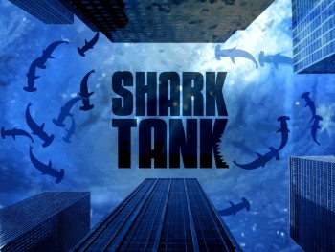
Picture: https://en.wikipedia.org/wiki/Shark_Tank

“Shark Tank” is a reality television program format which shows how entrepreneurs pitch (make business presentations) in the hope of securing investment finance from a panel of five investors or "sharks," who decide whether to invest in their company or not. At the end of the project you will need to present your business plan in a way of “Dragon’s Den”.

Recommended video: https://www.youtube.com/watch?v=Fb1AaUhM2PE
Your business is supported by Government!
Slide 47-48: Each country supports developing for new business. Here are links to supporting web pages from you own country:

Latvia
https://startuplatvia.eu/welcome-pack,
https://www.eu-startups.com/2020/07/latvias-startup-ecosystem-at-a-glance/

Sweden https://sweden.se/business/how-to-start-a-business-in-sweden/

Estonia
https://investinestonia.com/business-in-estonia/establishing-company/establishing-a-startup/

Finland
https://www.businessfinland.fi/en/do-business-with-finland/startup-in-finland/startupkit/establishing-a-company/

Remember! Your business plan doesn’t need to be long. Try to make sure that you are as concise and clear as possible and that you can refer back to business plan and update in the general course of running your organisation. Once you have a draft of your business plan it is a good idea to review it in order to assess its strengths and weaknesses, address any gaps and ensure it’s as clear, concise and logical as possible. Does the business plan present a strategy for achieving your aims and your mission? How sustainable is your approach? Would it appeal to the investors?

Task! Please fill One-pager template from Appendix II after this lesson and send it to your expert according the deadline.

Outline for SESSION 2

Table below summarizes the outline and estimated time for the entrepreneurship lesson for session 2. Topics and materials related to each chapter are presented in the following sections. Adaptions to the learning material are encouraged.

This project’s “ChangeMakers – Start-ups for sustainable environment created by youngsters” lesson is supposed to give a basic understanding about how to create a business plan and what does it means to create a business within circular economy.

Order | Chapter | Estimated duration
0 | Lessons learned from the last time | 5 (min)
I | What is The Strategy and why do you need it as entrepreneur? | 15
II | Entrepreneurship and circular economy business models | 15
III | Questions and answers | 10

0 preparations: lessons learned from the last time
Practical task: discuss your impression form the Session 1. What are the most important things in Entrepreneurship that you have learned, in your opinion?

What is The Strategy and why do you need it as entrepreneur?

Slide 49-50: The challenge of strategy is to “develop an integrated view of the workings of your business and how it creates and captures value within its operating environment”. [6] So, instead of concentrating on one piece of the strategy puzzle, business founders should familiarize themselves with the basic principles of the field. [6]
To begin, you can use this single index card to sketch your business. Source: Kevin J. Boudreau. [6]
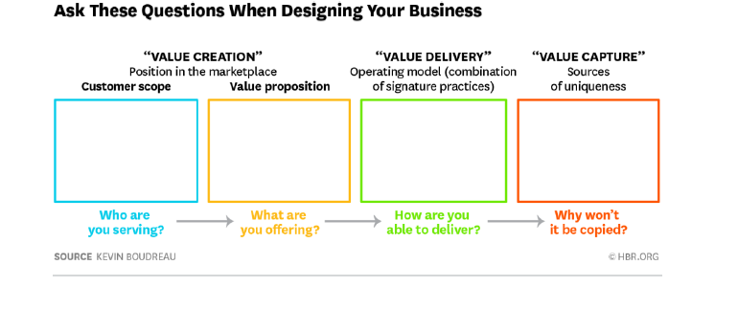
What Value Are You Intending to Create, and for Whom? Customers buy products and services because they see value in them. The first step toward a successful strategy is to clarify how you plan to create value, and for whom. That means defining who your customers are. That’s the first blank space on the index card above: Whom are you serving? Your customers may be defined by any number of characteristics — age, geography, interests.
The next step is to define your value proposition, e.g. a job to be done or a problem you try to solve. What are you offering? Key questions to ask include: What dimensions of a solution does your customer value, is it speed, cost or other things? In what dimensions is your solution better than the other company’s? Where is it worse?
You can think of this value creation as similar to a position on a game board. Your position is defined by the combination of your customer scope and your value proposition. If you’re not sure how to answer these first two questions, think about your customers and their preferences. What do they want more of, and what do they want less of?
How Do You Plan to Deliver That Value? In defining your position in the market, finding out how you’ll create value and for whom, you also need to define your operating model. The operating model is “the set of choices and practices defining how to carry out the business, that need to work together”. It’s about doing things that support each other, to create an entity that’s more valuable than the sum of its parts.
To start, think about the steps in your value chain, and list any key practices that appear to separate your company from other companies. Then think about how those practices fit together. Are there activities that make other activities more valuable? Finally, think about how these practices connect to the position you’ve drawn out. How do these matching activities create value for your customers?
What Is Your Competitive Advantage that makes you unique? The last question on the index card is perhaps the most important one: Why won’t anybody copy you? Even if you make a great product sells well, if competitors can easily enter the market and copy you, your profits might disappear.
Sources of competitive advantage come basically in two broad categories. Resource-based advantages are based “in unique assets or inputs that are valuable, rare, hard to imitate, durable, and specific to your organization”. Position-based advantages involve “your role and the position you occupy in your industry — things like scale and incumbency or network effects and early entry”. What are resources in your business that would be hardest for competitors to copy? What are the advantages of your position? What would keep another company from replicating your operating model? [6]

Entrepreneurship and circular economy business models

Circular economy offers various business opportunities in the future. Moreover, the overuse of natural resources drives regulators (regulatory pressure is increasing), investors and companies towards sustainability [7]. Basically, it’s a never-ending source for innovation, new business ideas and smart solutions. As was learned during the ChangeMakers Circular Economy lesson, we are shifting from a linear economic business model “take, make, waste” into a more circular economic business model.

Slide 51-52: One of the core ideas of the shift towards circular economy is “Better customer values can be delivered through offering outcomes instead of selling products”. The way it is shown on the figure below, instead of selling an engine to the customer, Rolls Royce charges the customer for a fixed charge per hour of operation, per ship and focuses on a specific customer need. In this way, the company may minimise inefficiencies, material resources and at the same time increase consumer experience.

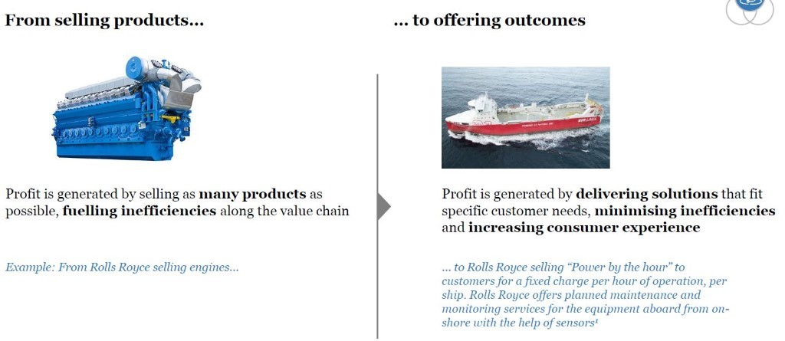
Source: Sitra Circular Economy Playbook for Manufacturing 2018 [7]

Practical task: Can the students come up with other examples? Here are some:

Company Tier: Instead of selling e-scooters to customers who want to travel from place A to place B, they rent e-scooters via mobile app. This serves the customer’s need of spontaneous traveling.

Netflix: Instead of selling DVDs to customers who want to enjoy movies at home, a monthly fee enables customers to have an unlimited access to a wide selection of movies and series.

Circular economy business models:

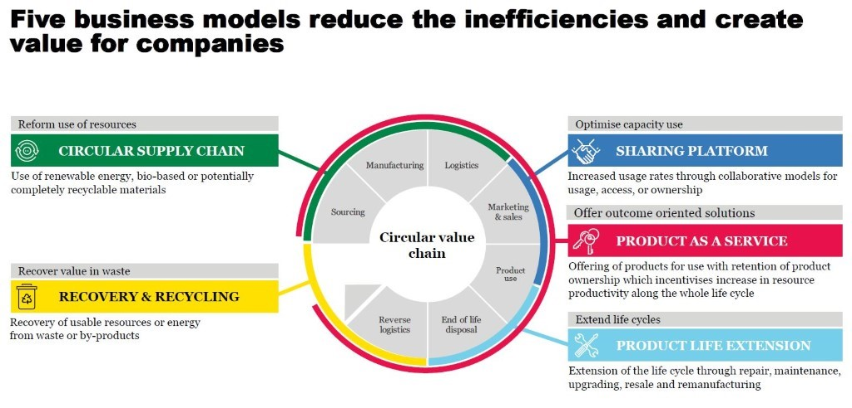
Slide 53-54:
Source: Sitra Circular Economy Playbook for Manufacturing 2018 [7]

There are several ways to start a circular economy business. Here is the 5+1 most important ones are presented:

1. Circular Supply Chain
Circular Supply Chain refers to processes in which customers are offered materials based e.g. on renewable energy solutions, bio-based materials or recyclable materials. In this model, possibly toxic, polluting and non-recyclable products and methods are replaced. Example: Finding solutions to replace cotton in clothing industry (growing cotton requires a lot of water).

2. Recovery and recycling
Recyclable raw material which may be obtained from consumers, construction industry, food industry, forestry and agriculture. Some websites offer the possibility to track these waste streams (e.g. Finnish materiaalikiertoon.fi). Note that in the future, this may only be a temporary business opportunity, as in many countries the goal is to reduce the amount of waste to zero. Example: ResQ -app through which customers may order left-over food from restaurants and shops, Swappie: selling used mobile phones.

3. Sharing platform
In this business model, individual ownership is replaced by common ownership. This form of common ownership may be applicable in sectors such as housing, transportation, tools and equipment and clothing. Example: rental companies for clothing.

4. Product as service
The customer pays for the benefit of a product, not from an ownership of such product. Example: Rolls Royce

5. Product life extension
Contribute to sustainable planning, materials and energy efficiency. Is it possible to dissemble the product and reuse the components of it? This is a huge challenge of the industry today. Example: company Fairphone

In addition, product life extension may include repairmen services and technical support.

+1 Consultation
There’s a growing need for environmental impact assessment for companies, also for expertise on resource efficiency and impact expertise.

Recommended video: https://www.youtube.com/watch?v=AEFqUh4PMmI - Little Green Bags: True Business Sustainability

References

[1] https://entrepreneurhandbook.co.uk/entrepreneurship/
[2] https://www.oberlo.com/blog/what-is-entrepreneurship
[3] https://www.khorus.com/blog/the-best-definition-of-entrepreneurship-ive-heard-so-far/
[4] https://www.forbes.com/sites/quora/2017/09/11/what-are-the-most-important-skills-entrepreneurs-need/?sh=5d07a5f5106c
[5] https://www.sba.gov/business-guide/plan-your-business/write-your-business-plan
[6] https://hbr.org/2017/10/a-short-guide-to-strategy-for-entrepreneurs
[7] https://www.sitra.fi/en/publications/circular-economy-business-models-manufacturing-industry/

Some extra videos:
https://www.youtube.com/watch?v=ZC0aJlslgYM – 5 myths about entrepreneurship
https://www.youtube.com/watch?v=DJyZEwV6rJU – 5 Youngest Future MILLIONAIRE Entrepreneurs
https://www.youtube.com/watch?v=lmNFLBhC4Fo - The Circulars 2016 – Young Global Leaders Award for Circular Economy Entrepreneur
https://www.youtube.com/watch?v=eYwKKFhn3hs - The Circulars 2019 – Event Highlights

Appendix I

Example of the Lean start-up plan

Wooden Grain Toy Company
Identity  Wooden Grain Toys manufactures high-quality hardwood toys for children aged 3-10. | Problem  Parents and grandparents are looking for high-quality, durable toys that will entertain kids and foster creativity.
Our solution  Our handcrafted toys are made from solid hardwoods, and are designed with sufficient moving parts to engage young children without limiting imagination. | Target market  The target audience is adults, specifically parents and grandparents who wish to give toys to their children or grandchildren.
The competition  Wooden toys are part of a niche market with companies of all sizes. Large companies include Plastique Toys and Metal Happy Toys, which sell internationally. Smaller companies sell locally in shops, craft fairs, or online. | Revenue streams  Wooden Grain Toys will sell directly to customers at craft fairs and online.
Marketing activities  Wooden Grain Toys will communicate with customers with an email newsletter, targeted Google and Facebook ads, social media, and in person at craft fairs. | Expenses  Materials for toys including wood, steel, and rubber  Craft fair fees and travel costs  Inventory space for products
Team and key roles  Currently, the only team member is the owner, Andrew Robertson. As profits increase, Wooden Grain Toys will look to add an employee to assist with social media and online marketing. | Next steps  As business grows, Wooden Grain Toys will advertise in target markets—especially in advance of the holiday season.
This example business plan is provided by the Small Business Administration.

Appendix II

Team/product name or logo
(if you already have one)
Describe your idea in one sentence. This is your position statement and can be your slogan.

Our write the name your product help(s) write who is your customer to increase or improve what? (customer gain) .

Problems we solve (customer pain) Write 1‒3 problems what your customers face today. Why is this a problem for them? Describe the problems in 2‒4 sentences

Benefits  (Your offer)  Describe in 2‒5 points  How will your product make people´s lives different?  How do they benefit from your product?  This develops further your positioning statement. Include a description of what it is, why it’s needed, and why it's better or different than other similar products or services. | Features  Describe in 2‒5 points  How does your product work? For example, is it an app, a website, a game, a physical product?  How does it look like? How does it feel?  What material is it made from?  What is special about it? Why is it good / convenient / fun to use? | Team progress  Write here important dates and steps of your team´s activities. For example:  So far:  Team Founded:  First mentor meeting with name of the mentor: …  Idea confirmed: …  First sketches: …  To come:  First prototype: …  Working prototype: …

Our help(s) …

Problems we solve (customer pain)

Benefits  (Your offer) | Features | Team progress  So far:  To come:

The study material does not propose the possible breaks that might be needed to keep the focus and good pace. Teachers are expected to estimate the need for breaks based on school and group specific needs.
The study material does not propose the possible breaks that might be needed to keep the focus and good pace. Teachers are expected to estimate the need for breaks based on school and group specific needs.

